Material Safety Data Sheet
- Identification of the substance
Product name: HT519 CAS No.9001-05-2
Product line: not applicable
Instrument type: not applicable
Supplier: LERKAM TECHNOLOGY COMPANY LIMITED
- Composition of ingredients
Component | Weight  (g/kg) | OSHA PEL | OSHA  STEL | ACGIH  TLV | ACGIH  STEL
catalase | NA | NA | NA | NA | NA
H₂O | NA | NA | NA | NA | NA
- Hazards identification
Emergency overview
NFPA Ratings: health=0 flammability=0 reactivity=0
Special definitions: A=Allergen CA=Carcinogen CO=Corrosive F=Flammable H=Harmful Ox=Oxidizer PB=Potential biohazard R=Reproductive S=Sensitizer T=Toxic T+ =Heavy Toxic W=Water reactive
- Principle routes of exposure
Principle routes of exposure: ingestion, skin and/or eye contact
Inhalation: none
Ingestion: ingestion may cause gastrointestinal irritation, nausea, vomiting and diarrhea
Skin contact: none
Eye contact: contact with eyes may cause irritation
Sensitization: the following chemical may cause sensitization
Medical conditions aggravated by exposure: none known
Additional information: none
Target organ effects: the following chemical has target organ effects
- First aid measures
Inhalation: consult a physician. Move to fresh air, give artificial respiration. If breathing is difficult, give oxygen
Skin contact: wash with plenty of water. If skin irritation persists, call a physician. Remove and wash the contaminated clothes before reuse
Ingestion: consult a physician. Do not induce vomiting without medical advice
Notes to physician: none determined
- Fire fighting measures
Suitable extinguishing media: use dry chemical, CO₂, water spray or alcohol foam
Unusual hazards: none known
Special protective equipment for firefighters: wear self contained breathing apparatus for fire fighting if necessary
- Accidental release measures
Personal precautions: use personal protective equipment. Evacuate personnel to safe areas
Environmental precautions: prevent further leakage or spillage if safe to do so. Prevent product from entering drains
Methods for cleaning up: never return spills in original containers for re-use. Sweep up or vacuum, then place into suitable clean, dry, dosed container, and label for disposal
- Handling and storage
Handling: protect contamination. Wear personal protective equipment
Storage: store in dry and ventilated place.
- Exposure controls
Engineering measures: not applicable
personal protective equipment
Respiratory protection: respiratory protection is not required under
normal use of this product
Hand protection: wear appropriate protective gloves to prevent skin contact
Skin and body protection: wear appropriate body protection to prevent skin contact
Eye protection: wear appropriate eye protection to prevent eye contact
Hygiene measures: avoid contact with skin, eye and clothing
- Physical and chemical properties
Color: brown liquid
Odor: slight fermentation odor
Physical state: liquid
Solubility in water: soluble
- Stability and reactivity
Stability: stable under recommended storage conditions
Polymerization: not applicable
Materials to avoid: avoid strong humidity
- Toxicological information
components | EPA-IRIS  oral reference dose  (Rfd) information | EPA-IRIS  inhalation reference concentration (Rfc) information | NIOSH  selected LD50s  and LC50s
HT519 |  |  | >10g/kg oral LD50 rats
Inhalation: no data available
Skin: no adverse effects
Oral: >10g/kg acute oral LD50 rats
Mutagenic effects: non-mutagenic in Ames test
Carcinogenic effects: no clastogenic effects in vitro mammalian cytogenetic test
- Ecological information
Bioaccumulation: not determined
Aquatic toxicity: not applicable
Eco-toxicity effects: not applicable
- Disposal considerations
Waste from residues/unused products: waste disposal must be in accordance with appropriate federal, state, and local regulations. This product, if unaltered by use, may be disposed of by treatment at advised by your local hazardous waste regulation authority.
- Transport information
Is product hazardous to ship? no
- Other information
Reason for revision: not applicable
References: 《Safety Evaluation of Product》 provided by Wuhan Sunhy Biology Co., Ltd.
Additional advice: none
Prepared by: technical center, Wuhan Sunhy Biology Co., Ltd.

This information data and recommendations contained here are based upon information believed by Wuhan Sunhy Biology Co., Ltd (WSBC), after reasonable investigation and research, to be accurate, however, WSBC doesn’t warrant the accuracy of this information. All materials and mixtures may present unknown hazards and should be used with caution. When necessary or appropriate, independent opinions regarding the risk of handling or exposure should be obtained from trained professionals. WSBC disclaims any warranty against patent infringement and the implied warranties of merchantability and fitness for a particular purpose. Customer’s sole and exclusive remedy shall be replacement of the product or return of the product and refund of purchase price, at WSBC’s option, in no case shall WSBC be liable for incidental or consequential damages, including lost profits.

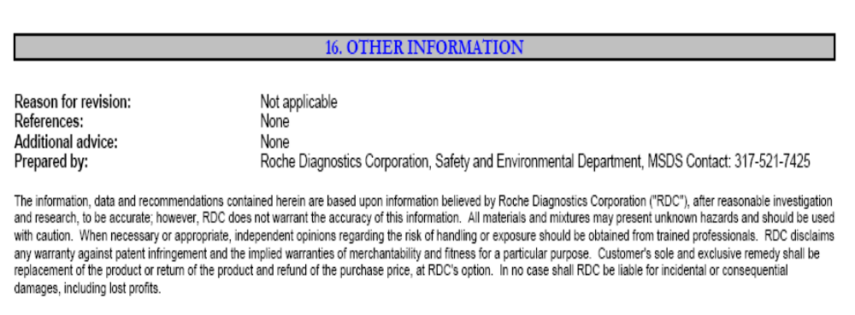
------------------------- End of Material Safety Data Sheet -----------------

